Project Planning Phase
Project Planning Template (Product Backlog, Sprint Planning, Stories, Story points)

Date | 2 Feb 2026
Team ID | LTVIP2026TMIDS89610
Project Name | Empowering India: Analysing the evolution of union budget allocations for sustainable growth
Marks | 8 Marks

Product Backlog, Sprint Schedule, and Estimation (4 Marks)
print | Functional Requirement (Epic) | User Story Number | User Story / Task | Story Points | Priority | Team Members
Sprint- 1 | Data Collection | USN-1 | As a developer, I want to collect Union Budget dataset (2021–2024) from Kaggle for analysis. | 3 | High | Mandrumaka Sekhar Babu
Sprint- 1 | Database Setup | USN-2 | As a developer, I want to create MySQL database and import cleaned budget data.. | 4 | High | Katragadda Naga Kavya
Sprint- 1 | Data Cleaning | USN-3 | As a developer, I want to clean and standardize revenue and capital columns. | 3 | High | Mohammad Asif Baig
Sprint- 2 | SQL Queries | USN-4 | As a developer, I want to write SQL queries for ministry-wise and scheme-wise analysis. | 4 | High | Kolluri Siri Pavan
Sprint- 2 | Tableau Connection | USN-5 | As a developer, I want to connect MySQL database with Tableau. | 3 | High | Mandrumaka Sekhar Babu
Sprint- 2 | Dashboard Design | USN-6 | As a user, I want to view category-wise and department-wise budget dashboards. | 4 | High | Katragadda Naga Kavya
Sprint- 3 | Data Visualization | USN-7 | As a user, I want revenue vs capital comparison charts for multiple years. | 3 | Medium | Kolluri Siri Pavan
Sprint- 3 | Story Creation | USN-8 | As a user, I want an interactive story explaining key budget insights. | 3 | Medium | Mohammad Asif Baig

Sprint- 3 | Web Integration | USN-9 | As a user, I want the Tableau dashboard embedded in a Flask web interface. | 4 | High | Katragadda Naga Kavya

Project Tracker, Velocity & Burndown Chart: (4 Marks)

Sprint | Total Story Points | Duration | Sprint Start Date | Sprint End Date (Planned) | Story Points Completed (as on Planned End Date) | Sprint Release Date (Actual)
Sprint- 1 | 10 | 3 days | 01 Feb 2026 | 3 Feb 2026 | 10 | 03 Feb 2026
Sprint- 2 | 11 | 3 days | 04 Feb 2026 | 06 Feb 2026 | 11 | 06 Feb 2026
Sprint- 3 | 10 | 3 days | 07 Feb 2026 | 09 Feb 2026 | 10 | 09 Feb 2026
Sprint- 4 | 08 | 3 days | 10 Feb 2026 | 12 Feb 2026 | 08 | 12 Feb 2026

Velocity:
Imagine we have a 10-day sprint duration, and the velocity of the team is 20 (points per sprint). Let’s calculate the team’s average velocity (AV) per iteration unit (story points per day)

Assume:
- Sprint duration = 3 days
- Average story points per sprint ≈ 10
AV=Total Story Points / Sprint Duration
AV=10 / 3 ​≈ 3.3 story points per day

Burndown Chart:

https://www.visual-paradigm.com/scrum/scrum-burndown-chart/

https://www.atlassian.com/agile/tutorials/burndown-charts
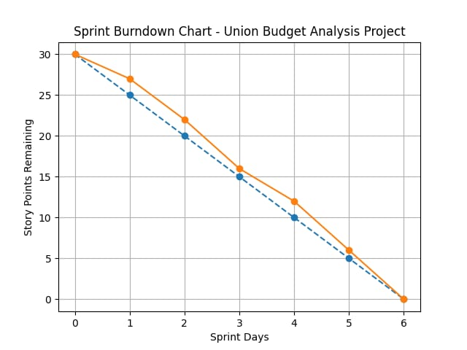

Reference:

https://www.atlassian.com/agile/project-management https://www.atlassian.com/agile/tutorials/how-to-do-scrum-with-jira-software https://www.atlassian.com/agile/tutorials/epics https://www.atlassian.com/agile/tutorials/sprints https://www.atlassian.com/agile/project-management/estimation https://www.atlassian.com/agile/tutorials/burndown-charts

